

Bucharest University of Economic Studies

Faculty of Cybernetics, Statistics and Economic Informatics

Economic Informatics in English Specialization

**Graduation Thesis**

Coordinating Teacher

Asist. univ. dr. Mădălina DOINEA-ZURINI

Graduate

Ștefania-Denisa CĂLIN

Bucharest 2019



Bucharest University of Economic Studies

Faculty of Cybernetics, Statistics and Economic Informatics

Economic Informatics in English Specialization

Mood- driven travel web application

Graduation Thesis

Coordinating Teacher

Asist. univ. dr. Mădălina DOINEA-ZURINI

Graduate

Ștefania-Denisa CĂLIN

Bucharest 2019

**Declaration regarding the originality of the content and taking responsibility for it**

I hereby declare that the results presented in this paper are entirely the result of my own creation with the exception of references made to the results of other authors. I confirm the fact that any material used from other sources (magazines, books and internet websites) is clearly indicated in the paper and in indicated in the list of bibliographic references.

Contents

1. Introduction 1

2. Trip searching progress 4

2.1. Trip searching online platform 11

2.2. The analysis of existent software solutions 13

3. Technologies Used 15

3.1. HTML 15

3.2. CSS 18

3.3. JavaScript 22

3.4. Bootstrap 26

3.5. PHP 29

3.6. MySQL 31

3.7. phpMyAdmin 33

3.8. WAMP 34

4. The solution’s architecture 35

4.1. Application’s description 35

4.2. Database 36

4.3. Diagrams 37

5. Mood-Driven Travel’s implementation 41

6. Conclusions 45

Bibliography 46

Annex 1 – The figure list 47

# Introduction

My graduation thesis has as main objective the implementation of a software solution in the form of a web application from the travel industry. I implemented an online application that helps the user to plan a new trip by providing travel ideas placed according to the user’s own mood – the way the he wants to feel in his future vacation.

The Internet has influenced very much the travel industry. Inventions like the railroads and the airplanes may have found a method over the physical barriers of travel, because of them now we are able to reach destinations that were unreachable due to the distances and the required time, but the Internet simply transcended them. Since its appearance, our world became increasingly connected, available and instantly accessible.

The history of the travel industry fascinates through its ancient beginnings, its evolution from one millennium to the next and by its flourish during the nineteenth century.

Our travel history begins with our earliest ancestors, known to science as *Homo erectus,* who lived until about 100,000 years ago. It is known that the species originated in East Africa, but, surprisingly, fossils were discovered in 1891 in Java, an Indonesian island, at about 5,000 miles away. [1] The only plausible answer is that our ancestor gradually left Africa and colonized other parts of the world. Human migration had begun even since and so too the history of travel. Unlike *Homo erectus,* today’s humans travel much further and our willingness to travel and explore allowed us to populate the planet.

Until few centuries ago, travel was a luxury and, if not, it was only made for survival or for the need of new, of unknown territories. The second reason drove explorers, merchants, or the various wanderers beyond the world in which they lived, to discover the wonders of the world.

In the 19th century, humankind witnessed the greatest expansion of wealth and technology production in all its history. The barriers lowered and the costs decreased, making travel reachable to millions of people. The combination of these factors with the growth of disposable income, the increased conditions of the burghers determined by the rise of the middle class in many markets and the changing attitudes of people towards travel, have enabled this industry to flourish like never before.

The technological evolution have changed and increased substantially tourism industry and today, nobody doubts its influence over the way we travel: from the holiday destination we choose, to the activities we do once we’re there.

Constantly in the process to satisfy our needs and wants, it seems that we feel the need to overcome the mental boundaries of everyday existence, which constantly seems to be a “close old clothing”, and to change some details of it. One of the ways to satisfy the need of self-transcendence of a person is traveling, consisting of a process to leave something well-known and understandable for the sake of getting into something unknown until then.   
The choice of the travel parameters, like its route, destination, duration, distance, depth of spiritual immersion in a new environment, the degree of risk to life, depends only on the individual interests of the traveler. The personality of the traveler plays an important role because it depends on which values he wants to acquire – fresh sources of information, sensations, thoughts, experiences, energy, etc.

Due to technology’s impact in our world, the travel business had to adapt and redirect its resources from the physical travel agencies to the cyberspace. Web design plays an important role in visitor’s first impression on the offered services. The design can be a determining factor in whether a visitor trusts the recommendation and the information provided.   
By providing an online application, the virtual travel experience will allow the user to find out all the necessary details and to explore the sights of mountains, beaches and city walks right from the personal computer or phone. In this way, the user’s experience is enhanced, both by the vast field of information, the helpful logistical details, the useful reviews from former travelers and the tips that will help him simplify the process of searching and planning.   
Also, the user has the possibility to access and to save the preferred trips ideas anytime, unlike the face-to-face meetings with the travel companies which are time consuming. The following can be achieved by using Internet, multimedia and databases: a rational and fast communication, direct contact with the market and its business partners, automation and integration of business process, and the most important – delivery and access of information.

Today, a percent of 74% travelers plan their trips on the Internet, while 13% use travel agencies to prepare the vacation for them. The internet is the top source for both business travel and leisure travel planning and, in the planning state, the searches are 48% related to the desired destination and 43% related to specific needs or wants.

The ratio changes when the trip reaches the booking state, the travel website or brand name becomes one of the most relevant search term and it’s closely followed by the specific needs or wants of the person. [2]

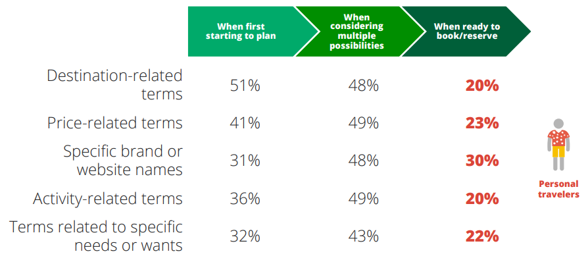

**Figure 1.1** Search Terms that Leisure Travelers use in Planning. Source: [2]

The webpage implemented in my project has as main search terms the destination’s continent and the psychological impact on the traveler, taking into account the feeling a certain trip idea transmits, which are also the most important factors, according to the studies made by Google Travel.

In the following chapters, the application’s content and development steps will be presented in detail, starting with the ways in which computer science development influences the travel market and continuing with the application’s implementation, the architecture, the technologies used, the obtained results and the conclusions based on them.

# Trip searching progress

Current approaches to the basic notions of travelling

The major changes in the world economy, materialized in significant increases of production in every country and the reduction of political and trade barriers between countries have led to the travel business development. The number of trips and countries that participate in the travel system raised, enhancing communication and growing the need of information with travel character.

On another side, this development brought difficulties in knowledge and correct evaluation of the travelling business, becoming harder to compute a relevant international comparison.

This was the situation which imposed the adoption of a unitary statistical system of tourism and the development of a common terminology, proposed at the International Conference on Travel and Tourism Statistics, Ottawa, 1991. These recommendations were adopted by law in 1993, at the 19th Session of the Statistics Commission of United Nations. [3]

The adopted clarifications concerned wide range of issues that could be grouped on multiple plans, as:

* The tourism notion’s content and its forms;
* The concept of visitor and the place, duration and reason of the trip;
* Tourism industry’s content and classification of composing components;
* Classification of tourist’s activities.

The main forms of tourism are: the domestic tourism (only in the country of origin), the inbound tourism (non-residents who travel in the certain country) and outbound tourism (residents of a country who travel in other countries.

Another classification based on the previously presented paragraph is: internal tourism, national tourism and international tourism.

Traveling’s economic role

The traveler is the center of attention for the travel ecosystem and the customization of the travel experience is concentrating the efforts of the stakeholders in this sector. It is essential a better understanding of traveler’s wishes, what prompts them and the way they behave. Even so, the evolution of technology made available to the travelers has caused them to change. From oral transmission, through fairs, printing press, telephone to television and electronics, the technology of the communication market changed.

The ways of change consist also of traveler’s pro-activeness regarding contents, the relation with other travelers and the reveal that some travelers are active managers of their own business modal, not only as users or consumers, but also as producers or developers of travel business, with, of course, an economic impact.

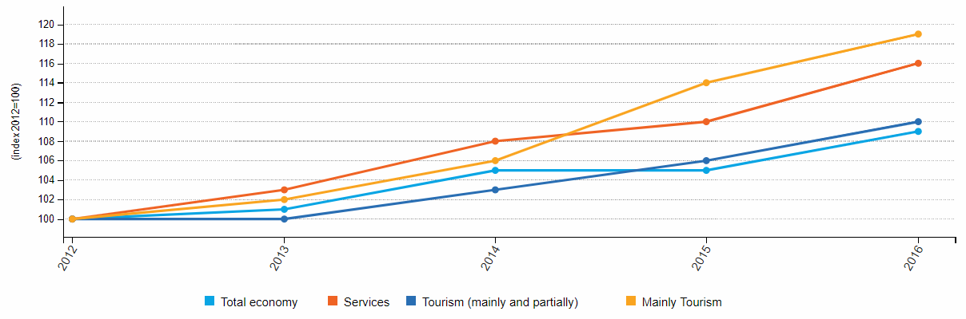

**Figure 2.1.** Evolution for different sectors of the economy, 2012-2016. Source: [4]

Travelling affects a wide range of areas, like: regional development, employment, education, the environment, consumer protection, health, safety, culture, new technologies, transport, finance, taxes and many more.

It all makes sense and it helps to see the big picture when taking into consideration the branches of the economy benefiting directly from the travelling, like: travel agencies, tour operators, hotels and other accommodation, restaurants and, in general, food industry, transport companies, tourist information centers, souvenir manufacturers, travel insurers, entertainment industry, maps distributors and travel equipment manufacturers.

The explanation of how travel industry keeps the economy going is that consumers tend to spend more time and, at the same time, more money when they are on a tour. One of the most important reasons is the phenomenon of the multiplier effect – how many times money spent by tourists circulates through the economy of the country.

Some countries are running their economies mostly on travelling incomes, countries like this are Switzerland and Singapore. More and more people are travelling from one day to another, with international arrivals expected to reach 1.8 billion by the year 2030. [4] In Europe, there are over 13 million people working in the traveling industry, in 2017. Also, 13% of them were young workers, with ages between 15 and 24 years old. [5]

Travelling generates new employment avenues to the native of the country, it provides foreign exchange earnings to the destination country, it raises the living conditions of the citizens and it helps in raising the gross domestic product (GDP) of the country. Another advantages are the infrastructure development, the contribution to cultural exchange and the help on preservation.

Throughout the last ten years, the travel area had experienced a substantial travel growth. Transportation venues - airports and rest stops have specific travel function and associated meanings. In contrast, the traffic congestion that appears both in-town and out-of-town intersections is the most critical negative facet of traveling at the desired destination. Hospital and gas stations, which offer support services, have specific meanings and functions in the communities. Even if the hospital is not a place where a person goes voluntarily, being viewed as having a low demand among the tourists, it has a positive impact on the community. In a similar way, gas stations have a positive utilitarian role and are considered neutral in the social life, serving both residents and travelers. Travel industry depends to a large extent on public authorities, for example, a travel service provider can’t attract customers only through the quality of the product, but must also take into account the quality of the infrastructure, the beauty and quality of the social and natural environment, as well as the level of other services distributed on the area. [6]

Electronic technology has allowed the participants to simultaneously communicate at long distances and introduces a new vision in the field of marketing communications. Furthermore, the arrival of new generations can also bring major changes in this sector of activity, the millennials having the potential to contribute to it due to their strong digital skills, their high degree of continuous and permanent connectivity, their search for experiences and their altruistic behavior.

A dominant feature of today's travelling is the considerable level of investment made for modern technology. Travelers have high expectations for efficient services and low tolerance when it comes to the barriers of global mobility. With today’s technology and data analysis, clients must be ensured that automation does not lead to disconnections between online and in-person exchanges. The last aspect highlights how important is the privacy of the consumer and the preservation of data throughout this process.

This sector of economy is sometimes the chance to relaunch after a period of crisis, other times it is the business card for a country, but, most often it is a source of environmental degradation, even if the conservation of flora and fauna is an important feature of travel industry, being the key element.

Appearance of travelling in computer software

In 1994, similar to the Yahoo style of listing of that time, appeared the first comprehensive catalogue of hotel properties around the world – named Travelweb.com, which later included a component to allow bookings making. The website was created by a small team under The Hotel Industry Switch Company’s (THISCO) John Davis.

The site was formed as a showcase for the company’s activity behind the scenes, but because of its uniqueness it gained popularity over many early visitor of the web. [7] This represents the year in which the Internet became the travel industry marketing tool and the customers started surfing the net to shop for their travel industry goods.

Beginning with the year 2000, the development registered in the search engines, the transport capacities and the speed of networks have influenced the number of travelers from all over the world to use technology for planning and documenting their journeys.

Information and Communications Technologies, in general, and the Internet, in particular, started to be considered as being one of the most effective tools for boosting the travelling industry. It have been observed that the users trust the Internet to obtain advice. This is what the organizations base on when they are trying, step by step, to engage customers in online conversations, and the main reason is that they want to create a sense of trust, to improve brand image and to strengthen the commitment to the user. These days, social networks, blogs or virtual technology plays a useful role in domestic travel, communication, skills and knowledge.

Present travelling influence in computer software

A travel website on the World Wide Web may be focused on trip fares, on travel reviews or on both of them. In 2018, approximately 587 million consumers booked travel plans online. [8]

The computers role in travel and tourism became essential. For example, when we go visit historic places and we want to found out more details about their importance, basically, their history, we don’t need a guide, a person, to explain us.

Nowadays, a search on the internet should do it, or we are offered a device that is actually a computer and helps us make the tour in a virtual way. These devices also use multimedia elements like music, sound effects or floor plans to recreate a realistic representation of reality.

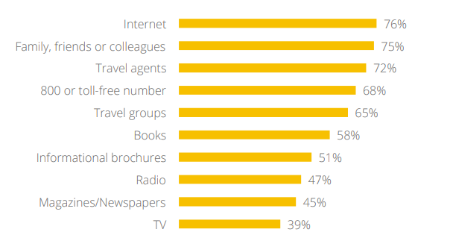

**Figure 2.2** Importance of sources for inspiring personal travel. Source: [7]

The majority of travel websites are online travelogues or travel journals – illustrated lecture about places visited by or experiences lived of a traveler. Both of the types are usually created by persons who travel individually and are hosted by companies that, in most of the cases, provide this information to consumers for free.

The revenue of these companies is generated through advertising or by service provided to other businesses. The styles in which they are produces and displayed are in a wide variety, often containing photography, graphics, maps and reviews that leads to acquiring unicity. The digital facilitates deeper customer relationship and, as I stated above, higher consumer standards among travelers. The travelers have the following expectations from a website’s services: the facility in using, the informational content, the utility, the security, the rapidity in operation and the personalization.

Traveling search on different means of communication

Smartphones are often used for inspiration for journeys in “snacking moments”, before planning. This is the first step in a trip planning and it plays an important role on the user’s perception. It is mandatory for the website to have fully functionality on the smartphones, not only on the computers.

It became a tour guide, a travel agency, a map, the best restaurant locator and, perhaps, an indispensable object, being by the traveler’s side during the entire journey. In this way, the user has all the pertinent and necessary information about the trip in the palm of their hand using an application which only requires internet connection.

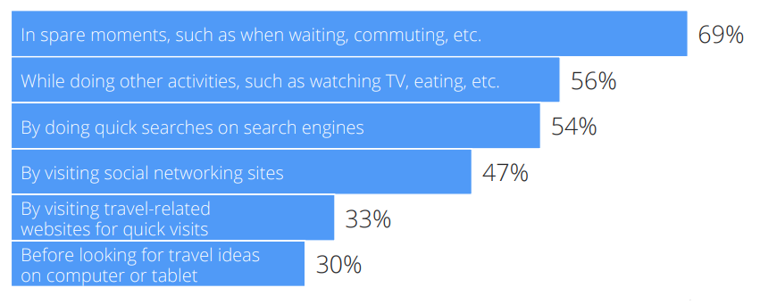

**Figure 2.3** Usage of smartphone for inspiring leisure travel. Source: [7]

It is well known that the main character in the new ways of travel is the smartphone.   
The wireless networks and the mobile networks allow the users to connect their communication dispositive to the global network, being widely spread across the world, in hotels, airports, pubs and many other places where people usually meet.

The 3G and 4G represent the third and, respectively, the fourth generations of mobile broadband Internet. The 3G connection is slower than the 4G one. Each generation of wireless broadband requires that the smartphone provider should make upgrades on its towers, and also requires that the user should upgrade his phone in order to send/receive signals through the new infrastructure.

A phone that uses 3G network cannot communicate through a 4G one, but 4G is designed to be compatible with the previous versions like 3G or even 2G.The fast development of technology represents the why there’s a need to adapt corporate services and communication to all means of communication.

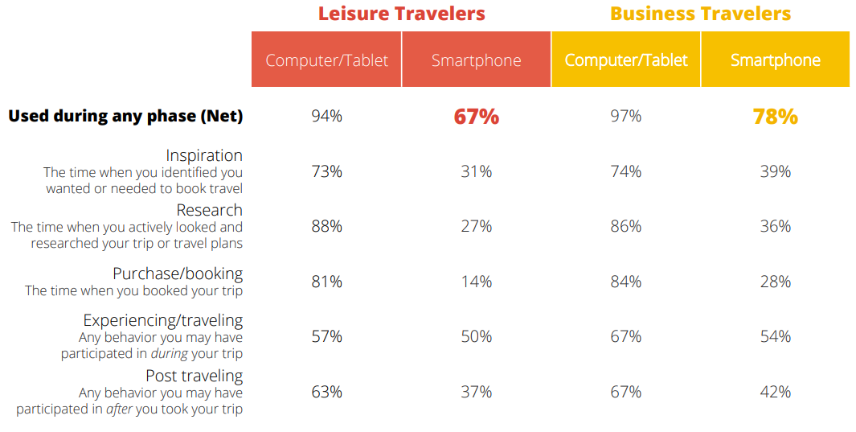

**Figure 2.4** Types of devices used by travelers. Source: [2]

In the picture from above it could be clearly seen that, in both leisure and business travels, all means of communication play a huge role. If a website is not adapted for every device, the user’s experience is worsened.

Presently, the smartphones users have the possibility to choose from a variety of application that can be installed on their dispositive for speeding up communication and providing all the necessary information.

The multimedia technology started its influence over the travel field, being considered an extensive support which offers an image or a tangible experience to the customer.   
Virtual tour is a new and welcoming mean of marketing, created in order to increase the satisfaction of experiencing in full depth and detail. It consists of the simulation of an existing location with the help of sequential videos or images. It provides excellent alternatives to fieldwork when the time or the expenses are an issue for the user. There are several methods and techniques available in order to create a virtual tour, for example: video tours, 360o (means that you can look in any direction: to the right, to the left or even backward) or panoramic tours, still photo tours, floor plan tours. A good virtual tour should be able to project images from different angles and scales in order to enhance the user experience. They can also provide an experience that can be repeated, feature useful in education, to reinforce learning for students. However, they suffer from limited navigational skills. [9]

## Trip searching online platform

The role of online platforms is to deliver benefits to both consumers and businesses by bringing together the consumer and the producer and allowing trades that would otherwise be harder to happen.

The diversity of online platforms in terms of activity, business model, sector and size is surprising, but there isn’t an apparent commonality between them. When examining the Web searching on specific domains, one user is able to increase its understanding of Web searching, to advance its knowledge of Web searcher’s information needs and to influence in a positive way the design of the Web information system. This applies the most to the travel domain. Although the extent and frequency of travel platforms, the patterns are similar across the countries.

There are 73% of American internet users that have obtained travel-related information from the Web, based on a report from the Pew Internet and American Life Project. Also, when it comes to benefits, almost all users, more accurate, 97% of them, in 4 of the most developed countries: Germany, France, Spain and Poland, think that Web searching improve convenience, gives greater choice area and increase transparency. Users estimate that information platforms have saved them 100 minutes in Poland and 50 minutes in France and Germany, in the past month.

With the dramatic growth of social media platforms that was received in the recent years, such as Instagram, about 40% of travelers said that the comments they read on social networks influenced their plans for vacation, while 50% inspired for and based their travel plans on other people’s experiences and reviews. [10]

Virtual communities become more and more influent in the travel domain, as long as the former travelers tend to create a higher degree of credibility to the user, rather than marketing messages. This kind of community helps the user to obtain information, to maintain and develop relationships and to make decisions concerning the future trip destination.

There are things that concern users, some of them being the privacy and security issues, the confusing functionality and the inappropriate content. Overall, users from all over the world are more likely to perceive benefits from than to raise concerns about the online platforms. [11]

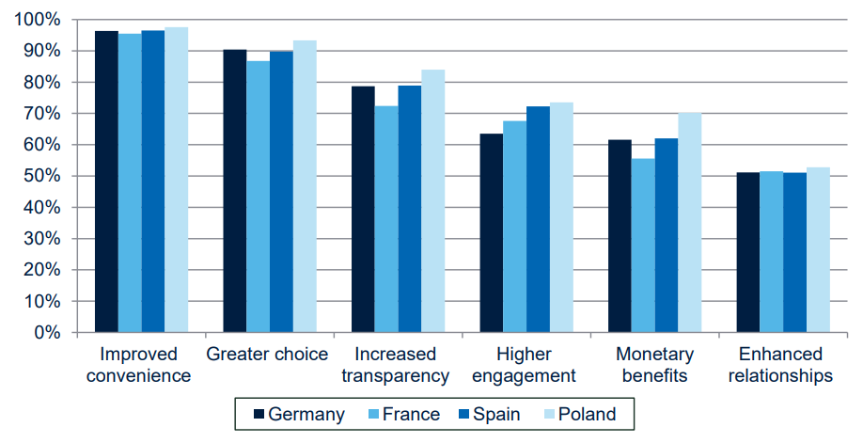

**Figure 2.5** Consumer perceptions of benefits. Source: [11]

Just with a simple search for travel information on any major Web search engine, for example Google, Bing, Yahoo, and Yandex, the user receives billions of results. Because it was observed a high use of the Web to locate travel information, there must be an examining and understanding of how people search in order to find relevant information. When searching, a dizzying collection of booking engines, blogs, interactive maps and wikis is displayed. Compared to the last decades, a travel feels less of a lottery because we, as consumers, feel more in control.

How online platforms evolved

In the last two decades, the search engines evolved considerably. The World Wide Web’s first generation, Web 1.0 was static and unidirectional. The webpages were represented as HTML pages with a content that was rarely updated. Website’s main role was to display information for anyone anytime and to establish an online presence. It wasn’t interactive and were mainly like brochures, the visitors having as option only to visit without impact or contributions.

Planners vs in-destination bookers

As it may have been expected, there are differences between types of travelers. There are the ones who book their activities ahead of their trip that spend 81% more on transportation and 47% more on lodging than those who wait to book in destination, making them a valuable audience, especially for companies like online travel agencies.  
Around 50% of experiences bookings are happening once travelers arrive at the destination. Also, the majority of those in-destination searches are happening on mobile. [12]

The essential features for travel a website

This is the main reason behind Google’s latest announce to travel brands, which consisted of a request to make websites simple, personal and mobile. These are some of the features used in order to attract, convert and retain travel customers.

After studies took place, it was observed that 14% of users are overwhelmed by the amount of travel information from the web, which explains Google’s urge for simplicity.

An amount of 42% stated that the desktop computer is an easier mean of communication options for searching travel idea, than on the other interfaces. And some of the users avoid to use mobile devices for searching travel idea due to the slow connection speed. [13]

## The analysis of existent software solutions

The travel industry’s development during the last decades led to a vast number of travel agencies and related websites. But, according to CleverTap, more than half of travel apps are deleted after one month.

World’s most trusted travel advices are the ones owned by TripAdvisor – the original and after 20 years, still the biggest social travel site existent on the web. The process of navigating on it was incredibly simple, consisting on the traveler’s activity to left a review of hotels and then, the fellow travelers found the reviews and decided whether to stay at a property based on what they’ve read or not.

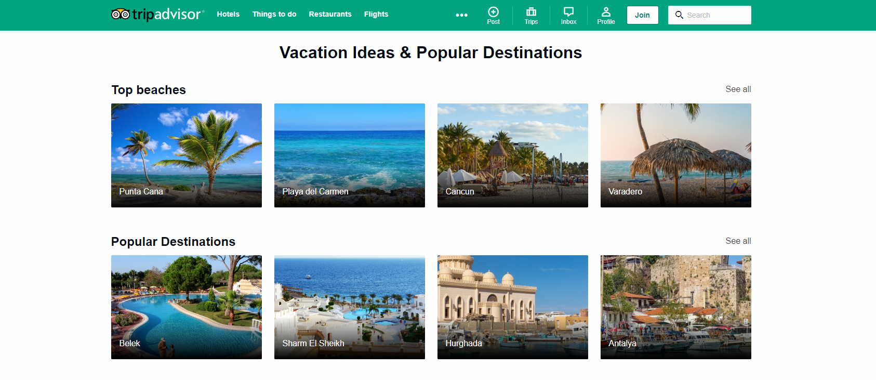

**Figure 2.6** TripAdvisor landing page. Source: https://www.tripadvisor.com

Its closest competitor is Kayak. The website is offering multiple services, like deals on flights, hotel rooms and rental cars. Its best feature is the pricing trends and the predictive algorithms on whether the prices rise or fall. Also, the travel alert services a user can benefit from after subscribing allows him to found out about travel discounts.

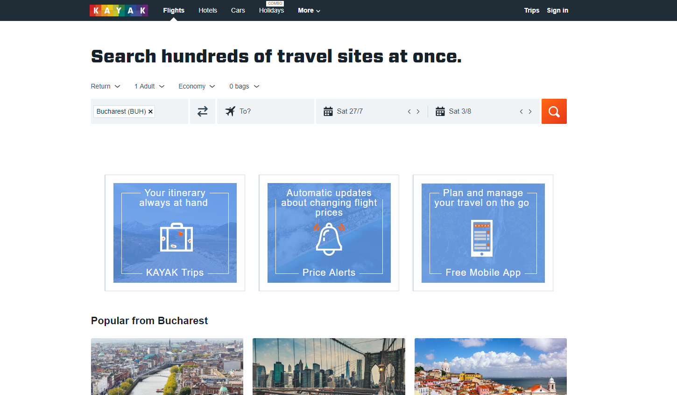

**Figure 2.7** Kayak landing page. Source: https://www.kayak.com

The apparition of social media created a wave of social media-fueled travelers, especially among the Instagram users. Today, influencers are everywhere on the Web and they promote different kinds of destinations. On Instagram or Facebook, pictures or videos of trips circulate rapidly and reaches a high amount of audience. Consumers also read the reviews situated in the post’s comment and are influenced by the new trends.

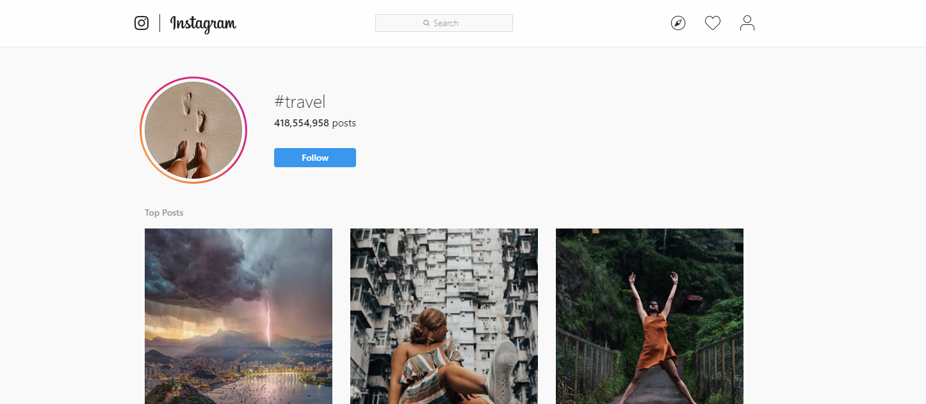

**Figure 2.8** Instagram travel page. Source: https://www.instagram.com

# Technologies Used

## HTML

HTML is a hypertext markup language that has become very common on the Internet. The HTML language defines the structure of the pages that you see in the browser. Every website on the Internet uses HTML to display information.

HTML defines the structure of the pages that you see in the browser thanks to HTML tags, the browser reads, processes them, and then displays tags to you on the screen, but in the form of HTML elements, you can even interact with some HTML elements using the mouse or keyboard.

To be precise from a formal point of view, it is correct to speak not an HTML page, but an HTML document. Your browser communicates with the web server using the HTTP protocol, sends HTTP requests and receives server responses, the body of which contains HTML.

Like the HTTP protocol, HTML was developed at CERN by Tim Berners-Lee in 1991 and was originally used by scientists to exchange scientific documents. HTML clearly defined the structure of the document and made it possible to highlight certain features of the text of the document, thanks to the simple syntax of the HTML language, it was widely spread not only in the scientific community, but also went to the masses.

At the moment, most often you can find sites using HTML 4.01, the latest HTML version is HTML 5, which all modern browsers correctly display. For each HTML document, you must specify a version, for this there is a special tag DOCTYPE, which says about the version of HTML.

The HTML language allows you to structure information in various ways: create tables, different types of lists, paragraphs, add images to a document, break a document into parts using headings, create forms for interacting with users, link different HTML documents to lists.

Web designers began to look for ways to beautifully present information. Some HTML tags were not used for their intended purpose, for example, <table>. The method of layout of web documents using this tag has become so popular that it even got a separate name - tabular layout. Previously, only using this method could accurately position the elements on the page.

With tabular layout, the web page design was created directly inside the HTML document. Other tags for styling and formatting were also used there. What problems did it cause? First, the HTML code became incredibly large in length, which negatively influenced both the weight of the document and its indexing by search robots. Secondly, in order to change, for example, the color of the h1 headers on each page of the site, we had to manually work out each of them. All this took a lot of time and effort. Also to format HTML documents and to make HTML tags unique, HTML attributes were invented, but at the moment no one uses HTML attributes to design documents, as there are cascading style sheets or CSS. There are exceptions, for example, some email clients cannot work with CSS and HTML attributes are used to design emails.

Today, thanks to the existence of CSS, it is possible to separate the design of the page from its content, as well as speed up the work process and significantly reduce the size of the HTML document. Those who have been creating websites for a long time have to get rid of old habits and learn to perceive HTML only as a markup language designed for structuring and organizing data. It is easier for beginners to learn new principles of creating web pages due to the lack of views on HTML as a tool for making pages look attractive. CSS is now responsible for this.

To structure HTML pages we can use the following tags:

* h1-h6 (heading) – these tags are intended to denote headings. Using these tags is very convenient to separate the text. For better understanding, imagine a book with chapters and subchapters. The title of the book is h1, the subchapters are h2, parts of the subchapters are h3, etc. It is better to place heading tags sequentially.
* p (paragraph) – This tag is used to designate paragraphs of text.
* ol, ul (ordered list, unordered list)– these tags are a handy tool for labeling lists (navigation links, items in the text, sequential list, etc.).
* dl (definition list) – this tag in conjunction with the <dt>, <dd> tags is used when creating a definition list, where <dt> is the definition term, <dd> is the definition description.
* div (division) – this is a block element that can be used to select a fragment of a document, as well as to logically combine several elements. With CSS, you can give the <div> block the necessary look and positioning, but the <div> itself does not change the appearance of the document.
* span (span) – the role of this tag is similar to <div>. But <div> is a block element, and <span> is a lowercase element. For example, if you need to change the style of a single word inside the <p> tag, you wrap this word into the <span> tag, add an id or class attribute with the name of the selector, and then assign the desired style to it in CSS.
* HTML5 semantic tags – to better structure your HTML document, use new tags to help you better describe the content. To distinguish the site header, navigation menu and footer from other content is hard, if all of them are marked with <div> tags. HTML5 tags such as <header>, <nav>, <footer> and others can help us to do this. They do not affect the appearance, but they help navigate browsers and search robots that have come to the site.

HTML5 is not a follower of the hypertext markup language, but a new open platform designed to create web applications that use audio, video, graphics, animation, and more.

The developer has a lot of new tools to improve the user interface: from more meaningful tags and improved cross-site and inter-window communications to animation and improved multimedia support.

The HTML5 standard has appeared quite recently and is still under development. Its main difference from the markup languages ​​of past generations of HTML 4.01 and XHTML 1.1 is the presence of specifications for working with multimedia applications, while maintaining the ease of reading code for humans and clarity of performance for computers and devices (the so-called user agents).

The main features that HTML5 brought into the development of web applications and interfaces include:

* **New improved markup of documents** – thanks to new markup elements, creating HTML5-based documents becomes faster and more quality, which leads to lower costs for creating layouts for web pages and applications. The semantics of the page increases - search engines automatically recognize where on the page is navigation, and where content is.
* **Drawing on the page** – HTML5 defines the canvas tag as a raster graphics canvas that can be used to display diagrams, computer games, or display other images on the fly. The canvas itself is a rectangle on the page in which you can draw what you want with JavaScript. HTML5 defines a set of functions called the “Canvas API” for drawing shapes, outlines, creating gradients, and transforming.
* **New form elements** – thanks to HTML5, developers have new features that were previously available only when using complex JavaScript libraries. Validation of the entered data is now happening "on the fly" right in the browser, which simplifies filling out the form.
* **Audio and video streaming support** – now you can easily embed media files directly into a web page without using “heavy” technologies like Adobe Flash or Microsoft Silverlight. Moreover, the HTML5 specifications allow direct control over the playback of these files, which can be useful, for example, when synchronizing video and subtitles to it.
* **Cross Platform Support** – HTML5 specifications are suitable for various user agents, which can be not only computer browsers, but also various portable devices. HTML5 creates various applications for smartphones, mobile phones, and home gaming consoles of the current generation.
* **Error processing** – documents may not always contain the correct syntax, but HTML5-compatible browsers, like their predecessors, use markup error analysis algorithms in documents to build the correct object model (DOM). A clear definition of requirements for user agents is made in order to achieve compatibility between browsers from different manufacturers. As well as the requirements for the syntax of the markup of documents in order to correctly display them in different browsers.
* **Geolocation** – some web applications with the user's permission may transmit data of his location. There are several ways to determine your position: by IP address, connection to a wireless network, cellular operator or via GPS equipment.

This is not all the features that HTML5 offers to developers and users. However, with all its merits, like all new technologies, HTML5 faces some problems. Most outdated browsers do not work with HTML5, and all specific tags are simply ignored, thus the display of pages in different versions of the browser may differ significantly. Since HTML5 is still under development, modern browsers can support it to varying degrees too.

## CSS

CSS (Cascading Style Sheets) is a formal language used to describe the appearance of a document created using a markup language (HTML, XHTML, and XML). The purpose of CSS is to separate what defines the appearance of the page from its content. If a document is created only using HTML, then it defines not only each element, but also the way it is displayed (color, font, block position, etc.). If cascading style sheets are connected, HTML describes only the sequence of objects. And for all their properties is responsible CSS. In HTML, it is enough to prescribe a class, without listing all the styles each time.

Such technology:

* provides a relatively simple and fast development, because once created design can be applied to many pages
* Increases flexibility and ease of editing – you can just edit the CSS for a certain element and the design for this element changes everywhere
* makes the code simpler by reducing the repeatability of the elements so it is easier to read for programmers and search bots
* speeds up loading time, because CSS can be cached when first opened, and only structure and data are read in subsequent ones
* increases the number of visual solutions for presenting content
* provides the ability to easily apply different styles to one document (for example, to create an adapted version for mobile devices or special styles for the visually impaired)

So the cascading tables serve not only to translate the design, but also drastically change the approach to site building, simplifying the work of developers and providing implementation flexibility.

The need to develop CSS was recognized by the W3C consortium in the 1990s. In 1996, the CSS1 standard was adopted, allowing you to change the font parameters, color, text attributes, alignments, and indents. In 1998, CSS2 was released, which added the possibility of using block layout, sound tables, generated content, pointers, and paged media. CSS3 version significantly increased the possibilities of styles: it became possible to create animated elements without using JavaScript, there was support for anti-aliasing, shadows, gradients, etc. The specification was divided into modules, each of which began to develop separately. Since 2011, the development of CSS4 modules has begun.

CSS can be described in simple terms as a set of rules that describe how an element should look. A rule consists of a selector and a block of declarations. In the Figure 3.1 you can see the example of the CSS rule.



**Figure 3.1** Example of the CSS rule.

The selector points on the element which style properties we want to describe in CSS for later applying them to it. The selector can be any tag that has to be formatted (size, color, etc.). If you need to set different styles for a tag or apply one for different elements, the classes are used. In Figure 3.2 you can see the syntax of the style declaration for the classes. The class name is given using Latin letters, it may contain an underscore or a hyphen. If you do not specify a tag, and start recording with ".class", then you can use the rule for any tag. If you list several classes for one tag, all described styles will be applied to it.

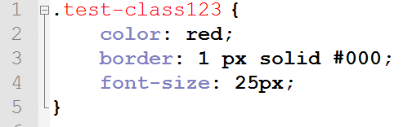

**Figure 3.2** Example of declaring styles for the elements with class "test-class123".

The ids specify the unique name of the element to change the style or select using a script. The name of the identifier consists of letters of the Latin alphabet, it is permissible to use a hyphen and underscore. To apply an identifier to a specific element, you have to set a unique id name and then in CSS put # sign and the id name of the element without spaces between them.

The declaration block consists of “property: value” pairs (always written with a colon) placed in curly braces. Entries end with a semicolon. CSS is insensitive to tabs, spaces, case. The choice of method of recording (indented column or just a line) is left to the discretion of the developer. If for one selector different values are written for one property, then priority is given to the lower entry.

There are several ways to link the Cascading Style Sheets to your HTML page for applying the declared styles:

* inside the tag using the style attribute. There is no need to specify a selector
* add a <style> tag with the type = "text / css" attribute
* connect an external style sheet: <link rel = "stylesheet" href = "path to style.css" type = "text / css" />

The third method is the most popular and recommended, because it allows you to fully enjoy the benefits of the separation of form and content provided by CSS.

CSS3 has revolutionized the web development world, because it brought a lot of new functionalities. This technology continues to evolve and introduce new features. CSS3 allows developers to re-style the background and borders of HTML elements in new ways.

border-radius is a useful property added in CSS3 that allows you to round the corners of the blocks. By default, they are rectangular, and this is not always necessary in design. Previously, such rounding was realized with the help of additional background images. Well, now we can rejoice that everything is so much simplified.

Now it’s enough to write “border-radius: 35px;”. The larger the value is, the greater the rounding will be applied. It is not necessary to set it in pixels - it is also possible in percent or em-units. Also depends on the size of the block. If the element is square, then it can be turned into a circle. For this you need to set a rounding of 50% or half the pixels of its width. You can round each individual corner. To do this, use the rules of border-top-left-radius, border-bottom-right-radius, etc. Another option to define the values ​​for each corner separately is to write four values ​​in border-radius. The values ​​are alternately set for the upper left, upper right, lower left, and lower right corners. Of course, since the property is part of the CSS3 specification, it’s wise to use it with vendor prefixes for cross-browser compatibility. Perhaps you yourself know them. These are –moz, -o, -ms and –webkit for support in Mozilla, Opera, IE and Chrome respectively, or rather, in older versions of these web browsers, because new browsers already understand the property without prefixes. These same prefixes can be used with all other properties from the CSS3 version.

**Linear and radial gradients** is one more part of the big CSS3 innovations about which you could write a separate book, because gradients have a lot of different parameters. But they are not created as a new property, they only expand the capabilities of the background property. To use them, it is enough to write in the background or background-image property: linear-gradient() or radial-gradient().

For example “background: linear-gradient (to right, aqua, yellow);” will set the smooth transition from the aqua color to the yellow color from left to right.

The “opacity” property allows you to set the transparency of the desired element. Values from 0 to 1 are accepted, where 1 is full opacity. With a value of 0 the element is not visible on the page, but it remains in its place. It must be said that the opacity acts on the element as a whole, and not just on the background. If there were text in our block, it would also become unreadable, and this should not be allowed. Therefore, text boxes usually use the rgba color mode as an alternative. Opacity is convenient to use for hiding / appearing elements.

**Shadows** were also added in CSS3. To add them, 3 properties are provided, and each has its own characteristics. All shadows have common settings, such as horizontal offset, vertical, blur, and color. Stretching is set only for box-shadow.

* box-shadow - usually used for blocks.
* text-shadow - shadow for text. It has the same parameters as the previous one, but it does not specify a stretch. It is worth noting that blur is also an optional parameter for both properties, it can be omitted.
* filter: drop-shadow() - perhaps, this property is the least known, and it is worst supported by browsers. In fact, if you try to apply it without prefixes, then, most likely, it will not work.

**Transformations** are another separate group of new css3 properties. Rather, the parameters and not the property itself give for the developers many possibilities. The transform works in much the same way as the filter, but has more complete support. Main transformation features:

* Move element horizontally, vertically, using transform: translateX(translateY for vertical displacement).
* Rotate elements to the desired number of degrees - transform: rotate (45deg). Values ​​from 0 to 360 and negative are accepted.
* Tilt items using skew. Also set in degrees.
* The ability to control block sizes using scale. You can set only scaleX or scaleY to increase the element only in width or height, respectively. Usually used to implement with smooth transitions.

**Smooth transitions** are also very important for animating objects in CSS3. To implement them, it is enough to use one property — transition, which can indicate the time during which the styles change. Usually set 0.5-2 seconds, although it is possible in milliseconds.In fact, the transition supports many more parameters that can be defined, but it can take too much text to explain each one.

## JavaScript

Like any programming language, the main task of JavaScript is to create a sequence of actions that will lead to a certain result. These may be “if-then” conditions, loops that create a specific sequence of actions, mathematical calculations, etc. The most important thing is that all these operations can be performed on web pages, in a browser window. Moreover, JavaScript can work without connecting to the Internet.

JavaScript is an interpreted programming language designed to interact with web pages. JavaScript is an implementation of ECMAScript and consists of three parts:

* The kernel (ECMAScript) is the core JavaScript functionality.
* Document Object Model (DOM) - for working with the contents of web pages.
* Browser Object Model (BOM) - to interact with the browser.

In browsers, by default, special software is built in, called the JavaScript interpreter, this is done so that the browser can execute code written in JavaScript. Usually, JavaScript is called client language, thus emphasizing that the script is executed on the client computer in the browser, and not on the web server.

Here are some examples that demonstrate the capabilities that can be obtained using JavaScript:

* **Mathematical operations:** On web pages very often there is a need to make certain calculations. For example, there are two text fields and you need to output the sum of two numbers in the third text field, which are entered in the first two. Using JavaScript, you can create a calculator and place it on a web page. Another situation, take some text string on a web page and you want to increase its size by 1.5 times. This can also be done with the help of mathematical calculations, by multiplying the current size by 1.5. There are a lot of tasks that require calculations in practice. JavaScript allows you to do all this.
* **Data processing in HTML-forms without connecting to the Internet and without using server side programming languages:** JavaScript allows you to verify that all required fields are filled and the data that they contain corresponds to the desired format (for example, if digits are required, then there must be digits and there should be no letters). Before sending data to the server, they are pre-tested by JavaScript. This reduces the load on the server.
* **Interactions with a user and events:** Different effects may appear on a web page, depending on what actions the user performs. For example when you click on the button you want to hide or show some elements on the page, or the appearance of a pop-up window when the mouse cursor went outside the browser window, or background dimming and fade-out effects. All of these actions and effects can be implemented using JavaScript.
* **Interactions with HTML elements on the page and managing of their content and styles:** When a certain event occurs (for example, a mouse click or any other), you can change the appearance (CSS styles) of elements on the page. You can also add some HTML tags or attributes to them, also when a certain event occurs.
* **Create and read cookies, retrieve visitor’s computer data:** A cookie can be used for session tracking, authenticating, remember specific information about the user like his name, password, last visited date etc. This is useful for websites and users both, if not used to steal privacy.

The release of the ECMAScript 2015 standard, informally called ES6, made significant adjustments to familiar things. The appeared functional is a superset of the language, aimed at solving actual problems. Creating arrow functions, as well as const, let and classes became a surprise for many. This standard made possible applying some new methodologies in JavaScript programming:

* **Destructive assignment or destructurization:**

In Figure 3.3 you can see the same code written in two different standards. In ES5, in order to transfer object properties to a variable, you need to write var one = obj.one. Such an operation must be performed with each property of the object. In the case of the new standard, as you can see, everything is much simpler and the code is much shorter. In the example above, I created two variables at the same time, and they assigned themselves two properties of the object in pairs.

Moreover, this operation can be done in one line, which is very convenient when you have a large object with an array of properties. Destructive assignment works with arrays too.

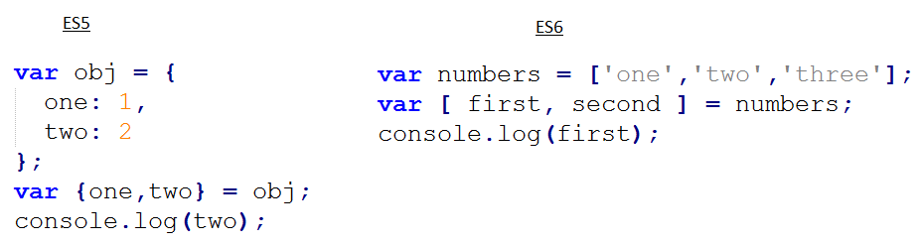

**Figure 3.3** Destructive assignment in ES5 and ES6

The same approach can be used when working with functions. In addition, so-called “default parameters” are supported. It is possible to specify what value the function argument will receive if we did not pass any value to it during the call. It should be noted that when transmitting any value other than undefined, including an empty string, zero or null, the parameter is considered to be passed, and the default value is not used.

* **Arrow functions:**

In fact, they are syntactic innovations and allow you to record the function itself much shorter. The syntax using () => at first seems a bit unusual, but the more you use it, the more you will like it, as the code with it gets shorter and cleaner, as it can be seen in Figure 3.4.

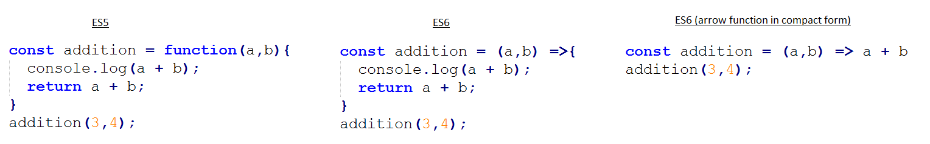

**Figure 3.4** Three different methods of writing the same function

* **Template strings:**

Web developers often deal with strings when they need to join strings and variables, and as a result get one big string. Often this code is too cumbersome, with a considerable number of spaces and plus signs for concatenation. Now everything is much better, as seen in Figure 3.5. Template strings save us from all this cumbersome code. A template string is created using inverse brackets `, and in order to put a variable into a string, you must put a $ sign in front of it and wrap it with curly braces. You can also wrap lines without any hyphens. In addition, you can call the function right inside the curly braces.

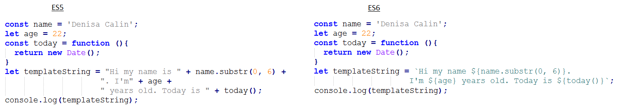

**Figure 3.5** Joining strings with variables in ES5 and ES6

* **Classes in ES6:**

Finally, the classes, which simplify the understanding of not clear for all prototypical inheritance, appeared in JavaScript. In fact, the internal implementation has not changed, but the visually new approach looks much more obvious.

You declare a class using clearer syntax, shown in Figure 3.6. Inside the class, you can set the constructor and other methods. If you need to inherit a class from the parent or base class, you can use the “extend” keyword.

Previously, if you had to call the method of the parent from the heir, you had to resort to all sorts of tricks that looked strange and were not always clear. Now everything is much easier. Finally, you can use the parent method call via super().

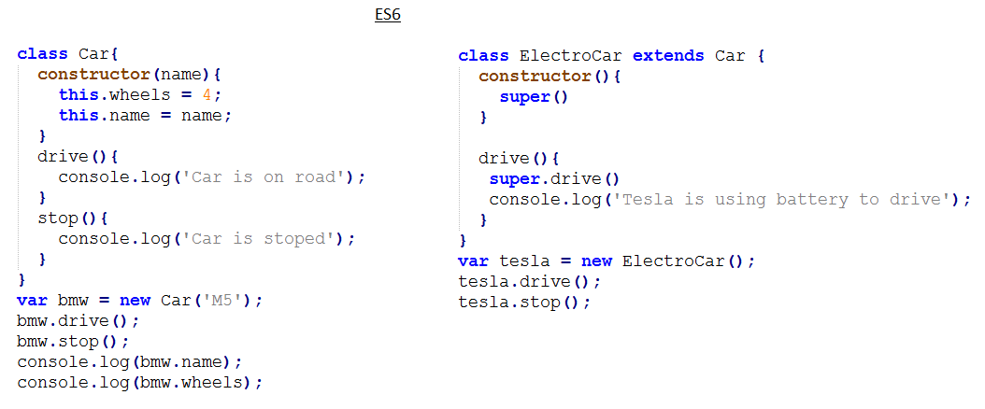

**Figure 3.6** An example of creating a class and its child class in ES6

## Bootstrap

The Bootstrap front-end framework is a set of ready-made tools for developing Internet solutions. In other words, while creating a website, there is no need to think about typography, responsive design, icons, indents, and other trifles that make up a truly beautiful design. You just need to download the package of tools Bootstrap and start using it.

After installing the bootstrap we get the following features:

* Ready CSS model with responsive tables and grids. You don’t have enough practice to create modern websites - it’s okay the bootstrap has taken care of almost everything and all you have to do is read the documentation and start creating.
* Beautiful typography and icons for your site, shown in Figure 3.7. All indents between words, lines and paragraphs are already thought out. Your site will look equally good on both big screens and smartphones. Icons will help revive the interface and make it much more attractive and interesting for the user.

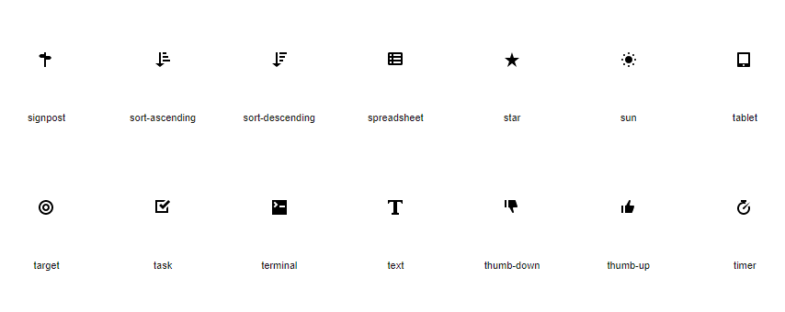

**Figure 3.7** Examples of the Bootstrap icons

Interactive solutions using JavaScript. Tooltips, interactive windows, drop-down lists, slider - in general, all you need to make the site alive and interesting to the user. All these solutions already have ready code, you only need to copy it to the site.

Not the last question that a web developer should ask himself is support of various browsers. The site must be correctly displayed in visitors’ browsers. And if most of the users use Internet Explorer 8, then you will have to develop a solution that will not scare customers. Bootstrap has already bothered about this and supports Internet Explorer 8th version. With the rest of the browsers, there is usually no such problem, because they automatically try to be updated as soon as possible.

To connect the framework files to the HTML file, you need to download the necessary framework from getbootstrap.com and copy its content into the project. After that, the developer must connect the files that he plans to use. The most popular files in bootstrap layout are:

* bootstrap.css / bootstrap.min.css. These files are an uncompressed and compressed version of the CSS code. For a project that is already running, bootstrap.min.css is usually connected. By using a compressed file, the download speed is improved. If the developer needs to view the code in the file, then he should connect bootstrap.css.
* bootstrap.js / bootstrap.min.js. Such versions of the file, but with scripts.
* The glyphicons files in the fonts folder. This folder contains more than 200 font icons.

The listed files are a typical set of frameworks. However, the developer has much more features. He can change frameworks according to his requirements.

The main element of Bootstrap is an adaptive grid. This element determines the value of this framework. The grid allows you to quickly create responsive templates. Most importantly, developers do not need knowledge and understanding of media queries. The layout of the site Bootstrap takes responsibility for the implementation of adaptability. To understand how to work with an adaptive grid, you can imagine it in the form of an html-table with rows and cells. There are two grid options:

* completely flexible
* with a defined maximum width

In the second case, the container class is used, which allows you to assign the required width in pixels to the general block. This block will not increase more than the specified value.

The bootstrap grid also uses container-fluid. The presence of this class indicates that the grid is flexible and does not have any size restrictions. Consequently, users will be able to see the site in full width, regardless of the size of the monitor.

According to experienced developers, the most important issue related to Bootstrap is the nuances of the 12-column system. Knowledge of these nuances opens up the way for developers to responsive adaptive layout.

Layout on Bootstrap provides the using of 4 classes designed to change the parameters of the blocks:

* lg - for large displays with a width of more than 1199 pixels (PC);
* md - for displays of average size up to 1199 pixels wide (laptops, netbooks);
* sm - for small displays up to 991 pixels wide (tablet devices);
* xs - for the smallest displays up to 768 pixels wide (smartphones).

In this system, in order to set the width, it is customary to indicate numbers from 1 to 12.

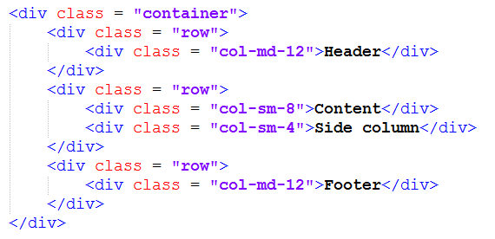

**Figure 3.8** Example of Bootstrap grid

Any experienced web programmer will understand this markup from Figure 3.8 without any problems. First of all, it is necessary to create a header that, in fact, may not be in the bootstrap grid. This is due to the fact that the header, as a rule, occupies 100% of the site width. In this example, I still keep the header in the “container”. Studying the above code, you could have a question: why is the class col-md-12 necessary. This class is required to send the following message to the browser: on devices belonging to the md class (laptops and netbooks), the grid width should be 12 out of 12 columns. In other words, 100% of the row width should be used here. On devices belonging to the class lg width will also be 100%. This is because the values for large displays are determined by the principle of inheritance. For smaller displays, this rule does not apply. Therefore, if the developer specified col-xs-6, the width of the columns on any devices will be equal to 50%. If the developer specified col-lg-6, then this width will be relevant only for large screens. About this feature should know any web developer who uses an adaptive layout Bootstrap 4. The code that uses classes col-sm-8 and col-sm-4 sends the following message to the browser: the width of the content block will be equal to 66% on all screens except the extra-small ones. But on the smallest displays, the default is 100% width. This kind of code is not just an example. In practice, this particular markup is used very often. As for the side column, its width will be 33% on small, medium and large displays. Consequently, on an extra-small screen, the default width will be 100%.

Among other features bootstrap can be noted the presence of the so-called **Responsive-utilities**. Thanks to these utilities, the developer has the ability to hide or, conversely, open blocks at the desired width. Thus, the developer has the opportunity to hide the side blocks on the displays of smartphones, add new layout elements on the screens of personal computers, etc.

In order to use the capabilities of the Responsive utilities, add classes to the selected block. To hide a block, use the class hidden. In Figure 3.9 you can see the example of its usage. In this example, the hidden-xs class is required to hide the footer on small displays. On devices with a large screen size, the footer will always be visible.



**Figure 3.9** Usage of the "hidden" class in Bootstrap

Reverse example: if a small block needs to be shown on a small display, the web developer should specify the class visible-xs-block. This code means that users will see the block exclusively on the displays of smartphones.

Classes of Responsive-utilities are written as follows:

* according to the programmer’s task he can use visible or hidden class if he has to show or, respectively, to hide the element
* to specify the display parameters, abbreviations of classes are used xs, sm, md and lg
* when specifying visible, you need to add some value: inline, inline-block or block

## PHP

PHP (Hypertext Preprocessor) is a general purpose scripting language intensively used for developing web applications. Currently supported by the overwhelming majority of hosting providers and is one of the leaders among the languages used to create dynamic websites. The PHP language runs on a remote server, which is why it is called a server programming language.

For example, a visitor from a laptop decided to access my site via the Internet. He is accessing my web server. The web server accordingly redirects the corresponding request to the corresponding PHP script. Further this PHP script interacts with various services. That is PHP language, here it is in this particular file that the client requested through the web server. PHP performs some specific set of actions, prepares the web page, gives it to the web server, and the web server gives it back to the client who requested this web page. Thus, the PHP language is as a kind of connecting link, the core, the central processor, which performs all automation operations on a remote web server. In general, it does everything that web programming languages do.

The main advantage of the PHP language is that it is focused on working with web servers. It has a lot of features that allow you to interact with server databases, such as MySQL, work with e-mail, work with the file system on a web-server. All these features are built into the PHP language. There are certain features that allow you to do this quickly and conveniently:

* Automatically extracting GET and POST parameters using predefined arrays for them
* Auto-Sending HTTP Headers
* Working with sessions and cookies
* Working with sockets
* Processing files uploaded to the server
* Saving files of different types using predefined functions
* Encrypting and decrypting data using predefined functions

PHP language can be used not only for web servers, and for creating websites and web applications. We can also use PHP in the command line. By running the terminal, we can run a PHP file with the help of the php command and execute the script that is in it and display some results in the command line.

PHP is a programming language with dynamic typing, which does not require a type indication when declaring variables, nor is the declaration of variables itself. Conversions between scalar types are often implicitly implemented without additional efforts (however, PHP provides ample opportunities for explicit type conversion).

The main advantage of PHP is the ability to add PHP code directly to regular HTML documents. The example of this feature in shown in Figure 3.10.

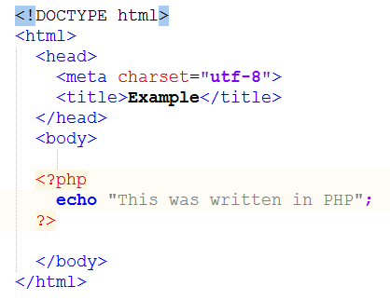

**Figure 3.10** Example of adding PHP code to HTML

## MySQL

MySQL is a database management system. A database is a structured data set. This can be anything: from a simple shopping list to an image gallery. To add, access and process data stored in a computer database, you need a database management system such as MySQL. Since computers are very good at processing large amounts of data, databases play a central role in computing, as stand-alone utilities, or as part of other software packages. It is a relational DBMS. A relational database stores data in separate tables. This adds speed and flexibility. Tables are linked by specific relationships that make it possible to combine data from several tables in a single query.

SQL part of MySQL is focused on Structured Query Language, the most common standardized language used to access computer databases. It is very fast, reliable and easy to use. If this is what you are looking for, you should try it. MySQL also has a very practical set of properties developed in very close collaboration with users. You can find a comparison of the effectiveness of MySQL with some other DBMS on the benchmark pages.

MySQL is Open Source Software, which means that the source code is open for reading and editing for everyone. Anyone can download it from the Internet and use it for free. Anyone can study the source code and modify it at their discretion.

MySQL was originally designed to process very large databases much faster than existing solutions, and has been used successfully in highly demanding industrial environments for several years. With ongoing development, MySQL today offers a rich and very useful set of functions. Connectivity, speed and protection make MySQL very suitable for accessing databases from the Internet.

It is a client-server system consisting of a multi-threaded SQL server that supports various functions, several different client programs and libraries, administrative tools and several programming interfaces. It has a lot of column types: signed / unsigned integer, 1, 2, 3, 4 and 8 bytes long, FLOAT, DOUBLE, CHAR, VARCHAR, TEXT, BLOB, DATE, TIME, DATETIME, TIMESTAMP, YEAR, SET and ENUM with fixed and variable length entries. All columns have default values. Using INSERT, you can insert a subset of the columns in a table; columns for which no values are explicitly specified are set to default values. MySQL has a full support for operators and functions in SELECT and WHERE parts of queries, full support for SQL GROUP BY and ORDER BY statements with SQL expressions, support for group functions (COUNT (), COUNT (DISTINCT ...), AVG (), STD (), SUM (), MAX () and MIN ()), LEFT OUTER JOIN and RIGHT OUTER JOIN support with ANSI SQL and ODBC syntax. DELETE, INSERT, REPLACE, and UPDATE return the number of rows that have been changed. Instead of this, you can set to return matched strings. To do this you have to set the flag when connecting to the server. The SHOW command, which is MySQL-specific, can be used to obtain information about databases, tables, and indexes. To find out how the optimizer performs the query, you can use the EXPLAIN command.

Function names do not conflict with table and column names. For example, ABS is a valid column name. To call a function, there is only one restriction: there is no space between the function name and the opening parenthesis “(“. In the same query, tables from different databases can be specified.

The system is based on privileges and passwords, thereby providing flexibility and security, and with the possibility of verification from a remote computer. Passwords are protected because they are encrypted when transmitted over the network when connected to the server.

MySQL can manage very large databases. MySQL AB uses MySQL to work with several databases that contain 50 million records. In addition, there are known users who use MySQL to work with 60000 tables with about 5000000000 rows. Up to 32 indexes are allowed for each table. Each index can contain from 1 to 16 columns or parts of columns. The maximum width of the index is 500 bits (this value can be changed when compiling MySQL). The index can be prefixed with a CHAR or VARCHAR field.

Clients can connect to MySQL using TCP / IP sockets, UNIX sockets, or named pipes. ODBC (Open-Database-Connectivity) support for Win32 makes possible to set connection to the database using MS Access and to use all ODBC 2.5 features.

## phpMyAdmin

All the problems of web developers and site administrators are solved by the phpMyAdmin server application, representing databases in a readable form and allowing them to be managed “in one click” without even knowing a single special command.

The database management program opens in a browser window. Its interface is concise and clear without additional instructions. There are also a lot of versions in other languages. The phpMyAdmin interface consists of a window divided into two parts. On the left is a narrow column in which the list of databases and the tree structure of each of them are presented. On the right is a working window in which the contents of the base cells, the menu of commands and service buttons are displayed.

In phpMyAdmin all the operations with cells and their contents - view, copy, delete and paste are made in one click. Most often, web developers and site administrators use the ability to instantly create a so-called database dump (copy) to transfer a site from one host to another. If desired, it can be obtained immediately in archived form.

Another interesting feature of phpMyAdmin is password recovery for entering the administrative part of the site. Just go to the Users cell or similar and copy the required username and password into your account. This program can successfully replace the administrative part of the site in case of its malfunction.

The ease of use and convenience of the phpMyAdmin interface predetermined its popularity and breadth of distribution on the World Wide Web. This program is included in the server software packages of most hosting providers that provide virtual platforms for hosting sites. In addition, it is part of the local server software package used by web developers to debug sites on home computers.

Administrators can easily create accounts for users, assign privileges to them, create and configure databases. Moreover, both users and administrators can use the same script – the only difference is that the user who does not have the necessary level of access will not have some functions — for example, choosing a database server, access to service databases and databases of other users, etc. But all the functionality within the framework created for him is fully accessible.

Developers have full control over their server, over all databases and tables, the ability to interactively execute SQL queries and even the initial functions of debugging invalid queries.

phpMyAdmin has built-in tools for carrying out ongoing work with databases and tables - maintaining, checking and repairing damaged tables, backing up and restoring from archives, exporting data from tables, both in SQL format and in more specific ones, such as LaTeX or PDF. To reduce the size of the data file, you can immediately compress the archive with the archiver - this is very useful for creating a copy of the remote database on the site on your machine.

Installing of the phpMyAdmin package is very simple, you only need to specify the data for access to the MySQL server - login, password and host name. After installation, another service database will appear, in addition to the database itself - phpmyadmin. In this database, the program stores its settings and other data it needs. The program allows you to perform any SQL queries on the databases, and this can be done both from a special separate query window, and for each table separately. On the most frequent requests, you can make special bookmarks and subsequently access them by clicking on the link.

## WAMP

WAMP is sometimes used as an abbreviation for the software stack for Windows, Apache, MySQL and PHP. It is derived from LAMP, which stands for Linux, Apache, MySQL and PHP. As the name implies, while LAMP is used on Linux servers, WAMP is used on Windows servers.

WAMP is easy to configure. WAMPServer has a graphical user interface to enable or disable individual component software during its operation. WAMPServer provides the ability to switch between many versions of Apache, multiple versions of PHP and many versions of MySQL that are installed, which provides more flexibility for development. If you want to use Perl with WAMP, you can configure Perl with WAMPServer.

# The solution’s architecture

## Application’s description

For my graduation thesis web application, I have developed a software which gives the users the possibility to get inspiration for, to select and to search ideas for their future trips based on the desired mood and continent. The application could be managed by a travel agency if the booking part is implemented, in order to allow the user to obtain the trip reservation and not only the proposal.

The results of my research, exposed in the previous chapters, indicated the fact that the websites from the travel area are the main source of inspiration worldwide.   
With an ample range of options, users that search for a journey idea are confused by the quantity of information found on different websites. The search flow would be similar to the following one: the user search for idea, when he found something that looks interesting for him, he selects the idea, and then, he wants to find out about possible activities at the selected destination. After that he starts looking for formal travelers’ reviews and experiences, and analyzes them. If he is satisfied by his research’s results and he’s still interested about it, he returns and adds the trip idea to his browser’s bookmarks or hopes to remember it.

The objective of my application is to help the traveler to identify more efficiently a trip idea that fits its personality and its wishes. Based on my research, the highest number of searches was related with the following two fields: location and specific needs or wants, and that is the reason behind the choice I made - to filter the travel destinations based on continent and traveler’s moods.

Due to the fact that the user experience should be personal, the interface displays to the user the following options: to register if he doesn’t have an account, and after that he has to log in. The user has access to the filters and to the list of travel idea, but to extend the website’s functionality he has to access his account. In order to help the user manage his preferences, he has the possibility to add ideas to his wish list, and, because preferences can change, to delete them. To improve the process of decision, reviews from former travelers are displayed.

In the previous chapters I argued the importance of a responsive design, meaning that it should adapt on every mean of communication, no matter the screen size and the resolution. The website designed by me is fully responsive, having elements that are stylized depending on the type of device (mobile, tablet, netbook, laptop, computer and 4K screens).

Its design is intuitive and so is its functionality, realized by adding representative icons and names for different page sections. According to studies presented above, user experience is improved if he doesn’t access an overloaded and overfilled user interface.

## Database

For developing my application I have used MySQL, as I previously stated in the above chapters. Its ability to process very large database faster than existing solutions, its connection speed and its data protection and relatively lightweight implementation made it suitable for use in the various online platforms.

The architecture of the database for the solution I have implemented consists of 5 related data tables:

* Moods – contains information such as the type of mood from the predefined set of moods, the URL of the representative icon stored on the server side, a short description to help user identify the correlation between his wishes and the filter, and a URL of the background image which has a visual impact on the user and it’s also stored on the server-side;
* Users – a table used to store data about the registered users which was introduced by them during the signup process. It contains fields such as name, email and password, which are further used to authenticate the user by its unique email address during the login process;
* Ideas – a table destined to the information regarding possible travel ideas using its title as a unique identifier, a short description to inform the user about the details of the trip, an expectations field that contains different tips and tricks that could help the user to bring the best out of the travel experience;
* Reviews – has as scope the storing of user’s feedback about a certain destination and is linked to the users’ and ideas’ tables in order to make a connection. It also includes the date on which the user wrote the review;
* Wishlist – is entirely made of foreign keys, having as purpose to store the interconnections between the travel ideas preferred by the user already contained by the database and the user himself;

The visual representation of the relational database used in this project was generated using reverse engineering from MySQL Workbench tool and is presented in the figure 4.1.

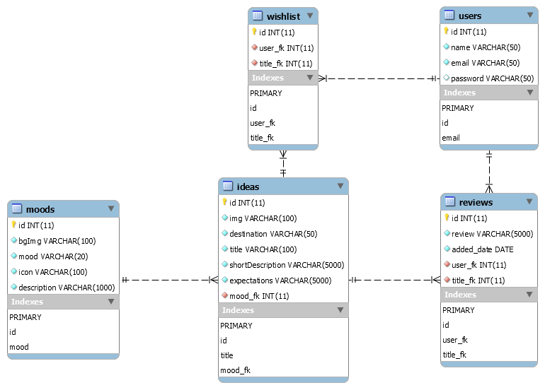

**Figure 4.1** Relational database diagram

## Diagrams

This chapter has the role to give the full particulars of the project and to reveal the design methodology that will lead to the implementation of the web page. The web application should optimize the process of searching trip ideas and provide information for better experiences.

It is designed for 2 types of users: Client and Administrator.

The client part of the web application we discussed about consists of:

* Homepage – where the client will see:
  + A menu from which he/she could choose:
    - Different filters to help him/her identify the preferred trip destination (travel moods, travel experiences).
    - List of destination ideas page

After choosing, a list of travel destinations will be displayed.

* + - Destination idea page

After a destination is selected, more information will be provided (place, description, what expectation to have), as well as a comment section where useful reviews from former travelers should be found.

* + - Wish list page

If the client likes the trip idea, he/she has as option to create an account and register his/her personal information in order to add the idea to wish list.

After that, after every log in, the client can keep track of his/her favorite holiday ideas.

* + Travel Planning Details
  + Most preferred trips ideas
* Sign Up page
* Log In page

The administrator has as tasks to:

* Manage the client database
* Manage the destinations database
* Verify the comments/reviews content

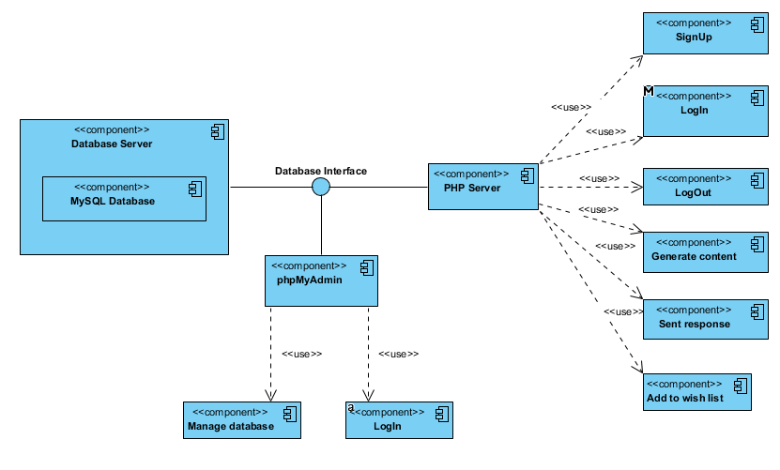

**Figure 4.2 .** Component diagram

In Figure 4.2 is shown the Component Diagram that shows the interconnection of the main components that define the logic of the web service and the possible ways of the database managing.

The detailed Use Case Diagram, that shows the relations between the actors of this system and the system itself, the types of users and their permissions for the different functionalities of the platform implemented for searching ideas for the different kinds of trips based on the user’s current mood.*………………*

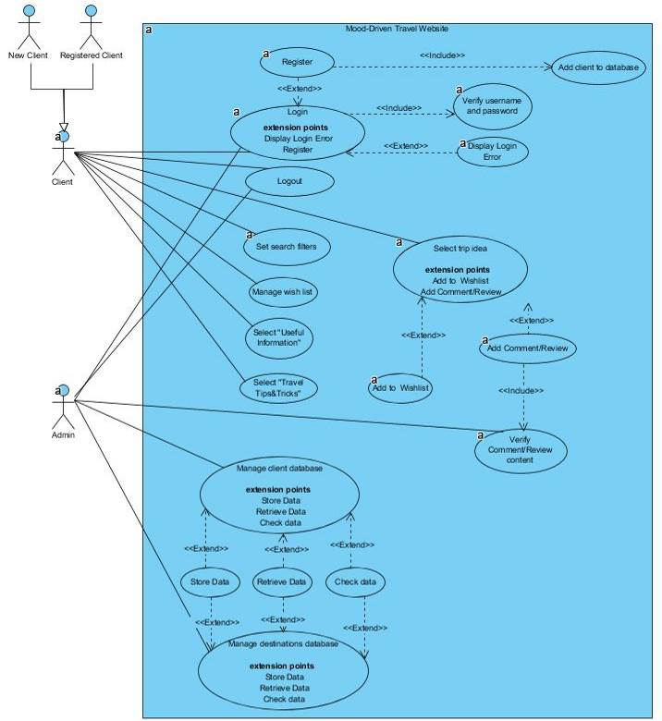

*………*

**Figure 4.3** Use case diagram

The next one is the Activity Diagram, which represents the activity flow in which the system is portrayed. The figure 4.4 shows how the activities are organized in order to allow the user to perform an adding to wish list.

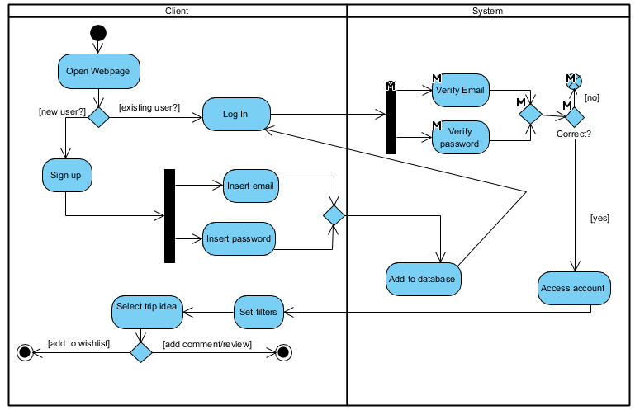

**Figure 4.4** Activity diagram

In the Figure 4.5 it’s displayed the sequence diagram that presents the steps a user has to make in order to add a trip idea to his/her wish list.

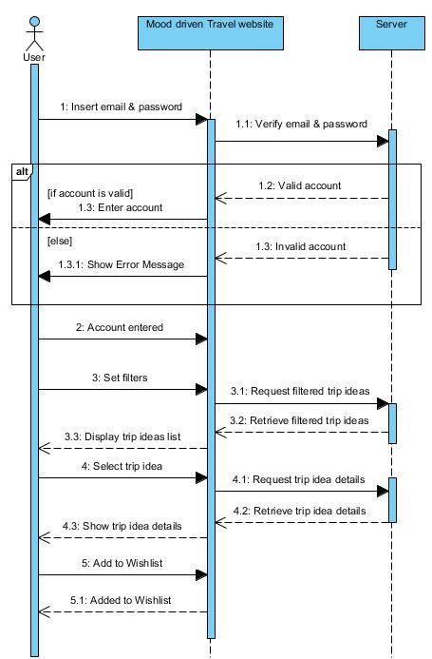

A user interacts with the website and, implicitly, with the server which verifies the correctness of account details, consisting in the email and the password, and which returns the requested data.

After that, the user is able to use all the functionalities provided by the travel web service. The filtering options are available both for the authenticated users and for the common visitors. But there are some features, like adding the trip idea to the personal wish list page and posting a review concerning a certain destination, that only logged users can access. The possibility to share your opinion with other travelers adds the personal and social part to the application.

**Figure 4.5** Sequence diagram

# Mood-Driven Travel’s implementation

My web application’s main purpose is to offer a simplified search for all the steps a traveler has to make when planning a journey. It offers ideas of travel based on some filters, the necessary preparations for obtaining the most of a travel experience, the supposed expectations a traveler has when he first visits a location and the possibility to store the preferred ones on the personal wish-list which further could be accessed by him.

The front-end part of the application was implemented using HTML5 – for the skeleton, CSS – for the design and JavaScript – for the interactivity obtained by selecting HTML elements and adding event listeners on them.

When a guest accesses the website from his browser, the HTTP request is sent to the PHP server. The layout of the page is generated using the set of the data retrieved from the MySQL database. Also PHP server checks if the user is logged in by checking the $_SESSION array. If the user was not authenticated, a block with login and signup buttons is generated. Otherwise the username and the sign out button will be displayed.

For the page with the authentication I have used JavaScript to make possible the dynamic generation of the form content without reloading the page by just clicking on the log in respectively sign up option.

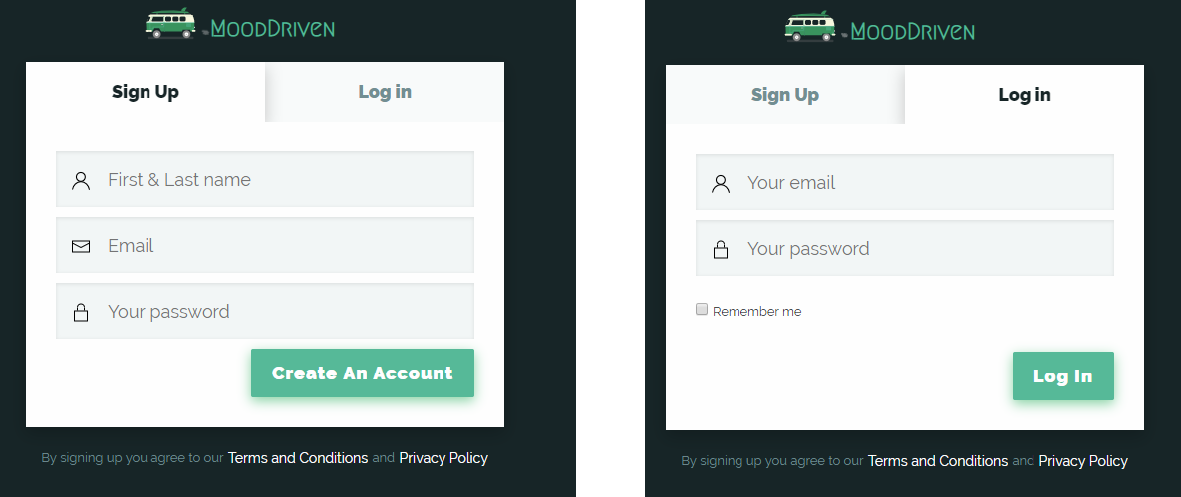

**Figure 5.1** Sign Up / Log In form

I have used HTML5 semantic tags to make the code structure more clear and logic. As the result the header, navigation menu, the main section and the footer content are distinguishable, being marked with the appropriate tags – <header>, <nav>, <main> and <footer>. When marked with <div> tag with a class that specifies the section, the code is harder to read, both by the developer himself and by other developers.

The power of scalable vector graphics animation (with the <svg> tag) was used to obtain the logo of my website. The logo is represented by a hippie van that appears to be moving thanks to CSS keyframes feature. The keyframes modifies the car’s position by changing the bottom property per each fraction of time, as it can be observed in Figure 5.2.



**Figure 5.2** Logo transition

The header component also has some effects that make it more attractive for the users’ eyes. In the initial state it is positioned on the top of the page and its background is transparent, so you can entirely see the background image of the hero element which is displayed on the full screen width and full screen height of the user’s device.

When user starts scrolling down the page’s content – the header’s styles are changing with the visible transition of 0.5 seconds. The background color is added with a box shadow and its position is changed from absolute to fixed which makes it to stay all the time on the top of the screen, as shown in the Figure 5.3.

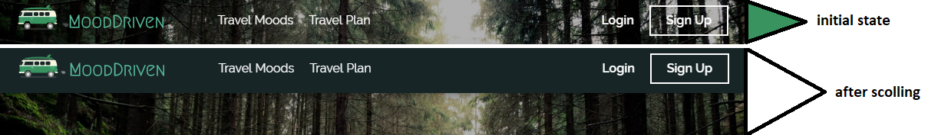

**Figure 5.3** Header transition

The most read travel ideas section has as components items of different sizes which consist of background image with dark faded overlay and one more overlay that contains the travel mood type with the corresponding icon and trip idea’s title. On hover, the faded overlay gradually disappears by increasing its opacity and the background image is zoomed in. The result of this effect can be seen in Figure 5.4.

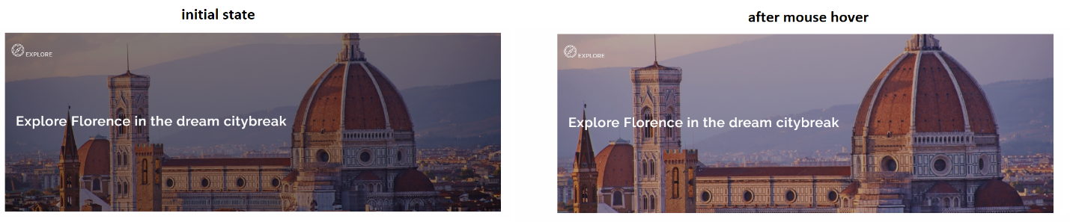

**Figure 5.4** Most read travel ideas section transition

Above the footer section of the page, it is situated a carousel element which represents resources that could be accessed by the user. Each resource is placed in a carousel item. By clicking on each one of them, the new tab with a resource’s official website will be opened. These items are animated by sliding the whole list with an interval of 5 seconds.

There also exist two buttons to make it possible to navigate between them manually. This feature was implemented using Bootstrap 4 and the results can be seen in Figure 5.5.

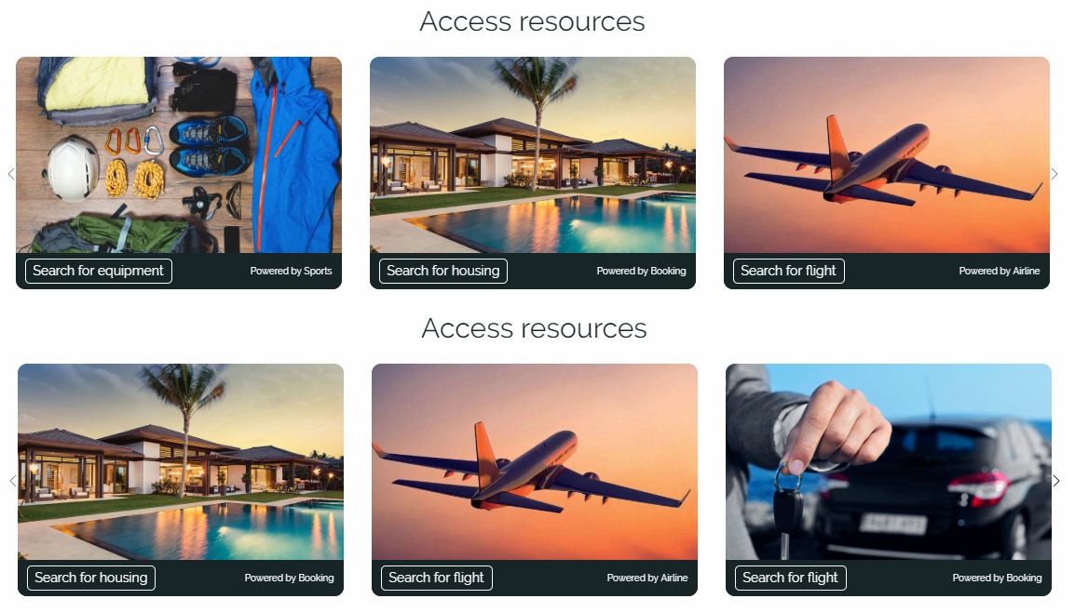

**Figure 5.5** Resources carousel

When the user navigates through the travel moods, section selected from the menu, the page – Travel Moods, which contains all added types, will be opened and will give the user the option to choose the preferred type.

There are 6 travel moods: Active, Adventure, Getaway, Explore, Relax and Romantic. The aspect of a section of the page is shown in Figure 5.6.

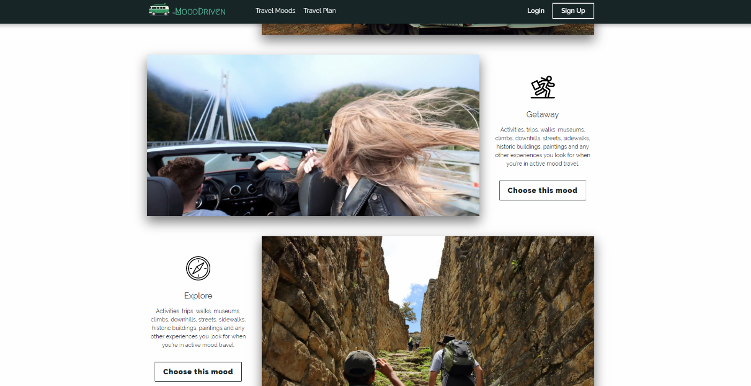

**Figure 5.6** Travel Moods page

After selecting the desired travel mood, the user is redirected to the list of ideas with the respective mood. He has as options two buttons: to go to the travel idea’s full specification page or to add the idea to wish list, and, as well, to remove it from there. The last feature was implemented using AJAX (Asynchronous JavaScript and XML) requests to not reload the page after adding or removing elements from the wish list. When user presses the button, the event onclick runs the function assigned to it. This function creates an AJAX request with the data about the selected idea and sends it to the PHP server, which stores the information about the user’s preferred idea to the database and establishes a relation between them.

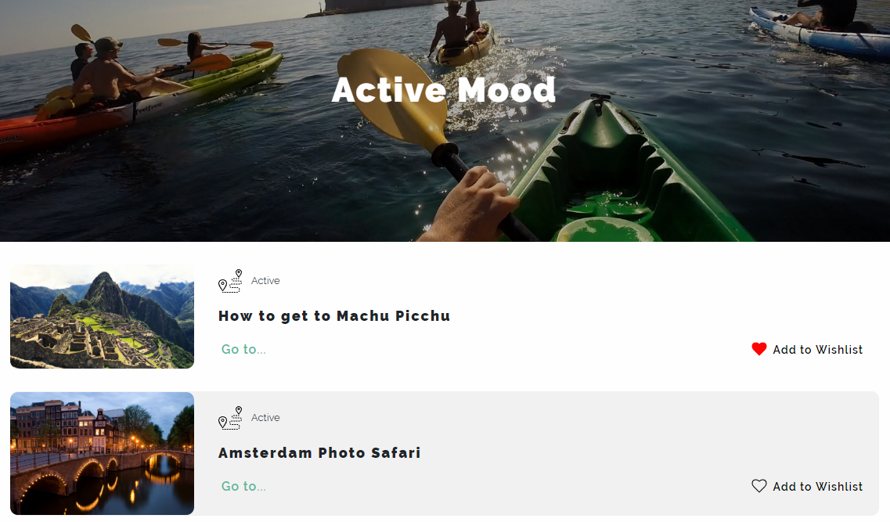

**Figure 5.7** Search based on travel mood filter

# Conclusions

As a conclusion for my graduation theses, I am going to present the strong points of the application, some improvements that can be made to this website, but also the degree of completion of the application.

The solution I implemented manage to achieve its initial purpose, namely to provide a place where people that want to travel could find ideas that are made for their psychical improvement and could inform about the necessary steps in trip planning. The user is able to sign up and to log in successfully. After authentication, more pages are available to use, and he have the option to save the traveling ideas that seemed suitable for his interests. Also, he can enter on the “Trip Planning” page and discover a detailed list of steps to follow when planning.

The implemented solution was adapted for all types of smart devices, giving the user the possibility to access it and have a nice experience with full functionality, indifferent of the mean of communication he has at his disposal.

The attractive design and animated visual effects improve the user’s experience who might maintain his attention for a longer period of time. The most part of the improvement would be made based on user’s feedback and on their requirements.

A drawback consists in the limited data from the travel ideas database that would improve if a travel agency would provide some recent and up-to-date information from the tourism sector. The lack of security might let the users exposed to potential hackers, even if no important details are stored, like the CNP, card details or address.

An improvement that would help the application’s improvement is founding real partnership, as none of the partnerships presented on the webpage is existent or a valid source of information, being simulated.

To conclude, an online travel page is a great source of inspiration among travelers and tourism is a continuous expanding domain, permitting all types of improvements. My opinion is that this type of platform can attract numerous persons in search of a real travel experience they would always remember about. Therefore, every travel website should also be based on user’s inner living, and not only a profitable business.

# Bibliography

|  |  |
| --- | --- |
| [1] | P. S. Stephen Gosch, Premodern Travel in World History, London: Routledge Taylor&Francis Group, 2007. |
| [2] | Google Travel, "The 2014 Traveler's Road to Decision," June 2014. [Online]. Available: https://www.thinkwithgoogle.com. [Accessed 12 January 2019]. |
| [3] | J. W. Daniela Turcu, Economia turismului, Timisoara: Editura Eurostampa, 2008. |
| [4] | T. O. Chris Lee, "Blurtit," Blurtit, June 2006. [Online]. Available: https://science.blurtit.com. [Accessed 23 03 2019]. |
| [5] | Statistics Explained, "Eurostat," Eurostat, Luxembourg, 2016. |
| [6] | M. S. M. D. A. W. David Snepenger, "Meanings and Consumption Characteristics of Places at a Tourism Destination," in *Journal of Travel Research Vol.45*, New York, Sage Publications, 2007, pp. 310-321. |
| [7] | W. D. Chalmers, On the origin of the species Homo touristicus, Bloomington: iUniverse, 2011. |
| [8] | B. Vidal, "Tourism and Technology: How Tech is Revolutionizing Travel," August 2018. [Online]. Available: https://www.wearemarketing.com. [Accessed 20 February 2019]. |
| [9] | P. Arvai, "Prezi," Prezi, 10 2018. [Online]. Available: https://prezi.com/. [Accessed 05 03 2019]. |
| [10] | Google Travel, "The 2013 Traveler's Road to Decision: Affluent Insights," January 2014. [Online]. Available: https://www.thinkwithgoogle.com. [Accessed 27 03 2019]. |
| [11] | Oxera Consulting LLP, "Benefits of online platforms," Oxera, Brussels, 2015. |
| [12] | J. Delago, "What travel marketers should know about people searching for experiences," May 2019. [Online]. Available: https://www.thinkwithgoogle.com. [Accessed 20 May 2019]. |
| [13] | K. May, "PhocusWire," 21 October 2013. [Online]. Available: https://www.phocuswire.com. [Accessed 22 May 2019]. |
| [14] | Refsnes Data, "W3Schools," Refsnes Data, 01 2019. [Online]. Available: https://www.w3schools.com. [Accessed 26 02 2019]. |
| [15] | J. Jung, "The Conversation," Edith Cowan University, March 2017. [Online]. Available: http://theconversation.com. [Accessed 28 March 2019]. |

# Annex 1 – The figure list

**Figure 1.1** Search Terms that Leisure Travelers use in Planning. Source: [2] 3

**Figure 2.1.** Evolution for different sectors of the economy, 2012-2016. Source: [4] 5

**Figure 2.2** Importance of sources for inspiring personal travel. Source: [7] 8

**Figure 2.3** Usage of smartphone for inspiring leisure travel. Source: [7] 9

**Figure 2.4** Types of devices used by travelers. Source: [2] 10

**Figure 2.5** Consumer perceptions of benefits. Source: [11] 12

**Figure 2.6** TripAdvisor landing page. Source: https://www.tripadvisor.com 13

**Figure 2.7** Kayak landing page. Source: https://www.kayak.com 14

**Figure 2.8** Instagram travel page. Source: https://www.instagram.com 14

**Figure 3.1** Example of the CSS rule. 19

**Figure 3.2** Example of declaring styles for the elements with class "test-class123". 20

**Figure 3.3** Destructive assignment in ES5 and ES6 24

**Figure 3.4** Three different methods of writing the same function 25

**Figure 3.5** Joining strings with variables in ES5 and ES6 25

**Figure 3.6** An example of creating a class and its child class in ES6 26

**Figure 3.7** Examples of the Bootstrap icons 26

**Figure 3.8** Example of Bootstrap grid 28

**Figure 3.9** Usage of the "hidden" class in Bootstrap 29

**Figure 3.10** Example of adding PHP code to HTML 31

**Figure 4.1** Relational database diagram 37

**Figure 4.2 .** Component diagram 38

**Figure 4.3** Use case diagram 39

**Figure 4.4** Activity diagram 39

**Figure 4.5** Sequence diagram 40

**Figure 5.1** Sign Up / Log In form 41

**Figure 5.2** Logo transition 42

**Figure 5.3** Header transition 42

**Figure 5.4** Most read travel ideas section transition 43

**Figure 5.5** Resources carousel 43

**Figure 5.6** Travel Moods page 44

**Figure 5.7** Search based on travel mood filter 44